**Clipper Circuits**

**Lab no#05**



**Spring 2021**

**CSE-206L Electronic Circuits Lab**

Submitted by: **Ashfaq Ahmad**

Registration No: **19PWCSE1795**

Class Section: **B**

“On my honor, as student of University of Engineering and Technology, I have neither given nor received unauthorized assistance on this academic work.”

Student Signature: ______________

Submitted to:

**Eng: Abdullah Hameed**

June 6, 2021

**Department of Computer Systems Engineering**

**University of Engineering and Technology, Peshawar**

**Definition:**

* **Clippers are wave shaping circuit that remove or clip off either positive or negative half cycle of the wave.**
* In some cases it removes the small portion of positive or negative half cycle.
* These are also known as clippers, clipping circuits, limiters, slicers etc.
* It consists of linear (resister) and non-linear (Diode, transistor etc) elements but does not contain energy storing elements.
* Clipper circuits are also known as protection devices.

**Uses:**

* As we know that electronic devices are very voltage sensitive and voltage of large amplitude may permanently destroy the device. So, in order to protect the device clipper circuits are used.
* If there is input voltage more than required voltage, than we can use clipper circuit to reduce it to required voltage.

**Note: In all clipper circuit input voltage is AC output is DC.**

## Classification of Clipper circuits

Clippers are basically classified in the following categories:

1. **Series clipper circuit.**

**Series clipper circuits are further classified:**

1. **Un-biased series clipper circuit.**

**It further classified:**

* **Positive Un-biased series clipper.**
* **Negative Un-biased series clipper.**

1. **Biased series clipper circuit.**

**It further classified:**

* **Positive biased series clipper.**
* **Negative biased series clipper.**

1. **Parallel clipper circuit.**

**Parallel clipper circuits are further classified:**

1. **Un-biased parallel clipper circuit.**

**It further classified:**

* **Positive Un-biased parallel clipper.**
* **Negative Un-biased parallel clipper.**

1. **Biased Parallel clipper circuit.**

**It further classified:**

* **Positive biased parallel clipper.**
* **Negative biased parallel clipper.**

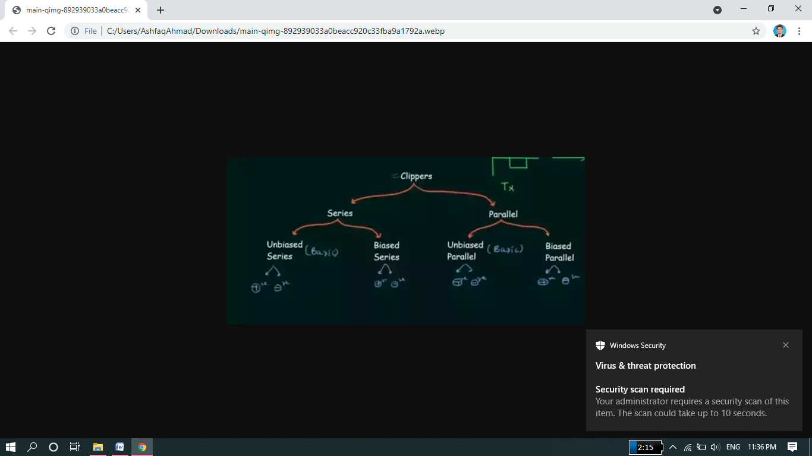

1. **Series clipper circuit.**

In series clipper circuit a diode is connect with Ac voltage source in series.

1. **Un-biased series clipper circuit.**

In un-biased series clipper circuit there is no extra Dc voltage source connects in series with diode. In case of un-biased, a complete positive or negative half cycle is removed.

* **Positive Un-biased series clipper.**

In this circuit a diode is connected in reverse bias in series with AC voltage source. In this case a complete positive half cycle is removed.

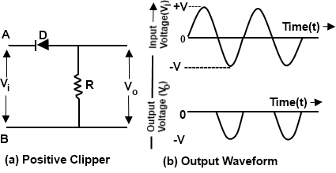

**Positive unbiased series clipper circuit**

**Proteus Circuit and Output:**

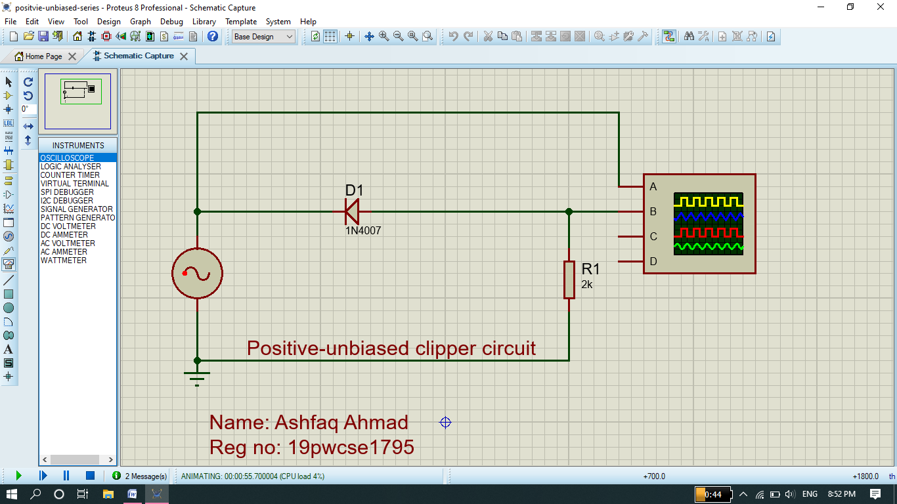

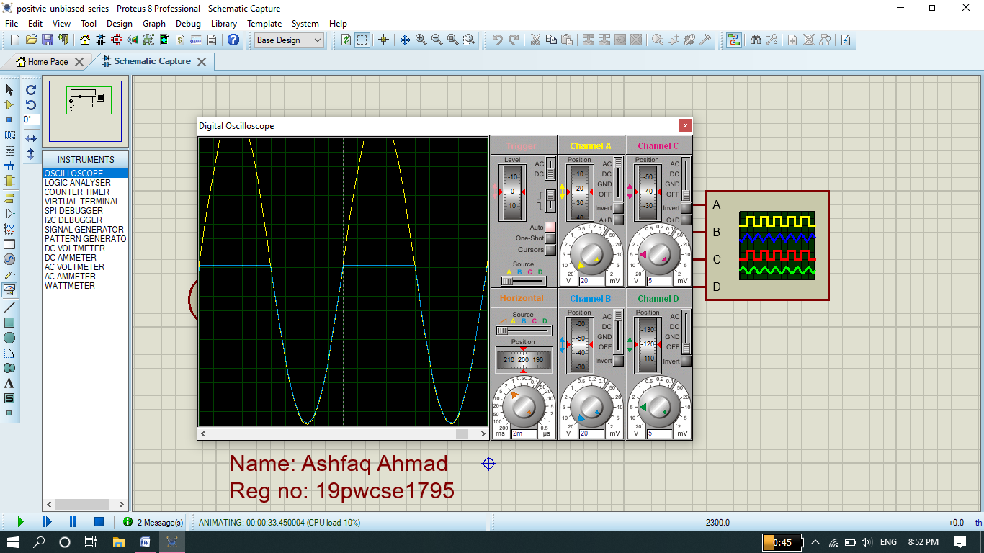

* **Negative Un-biased series clipper.**

In this circuit a diode is connected in Forward bias in series with AC voltage source. In this case a complete negative half cycle is removed.

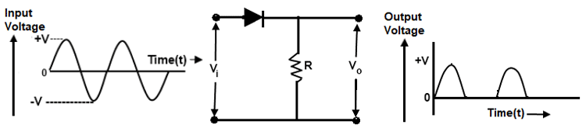

**Negative Un-biased series clipper circuit**

**Proteus Circuit and Output:**

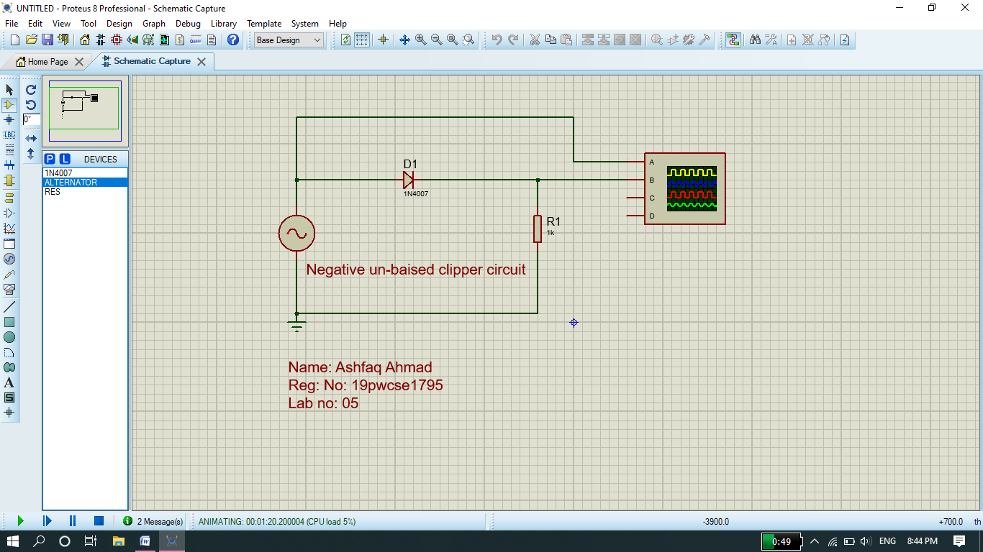

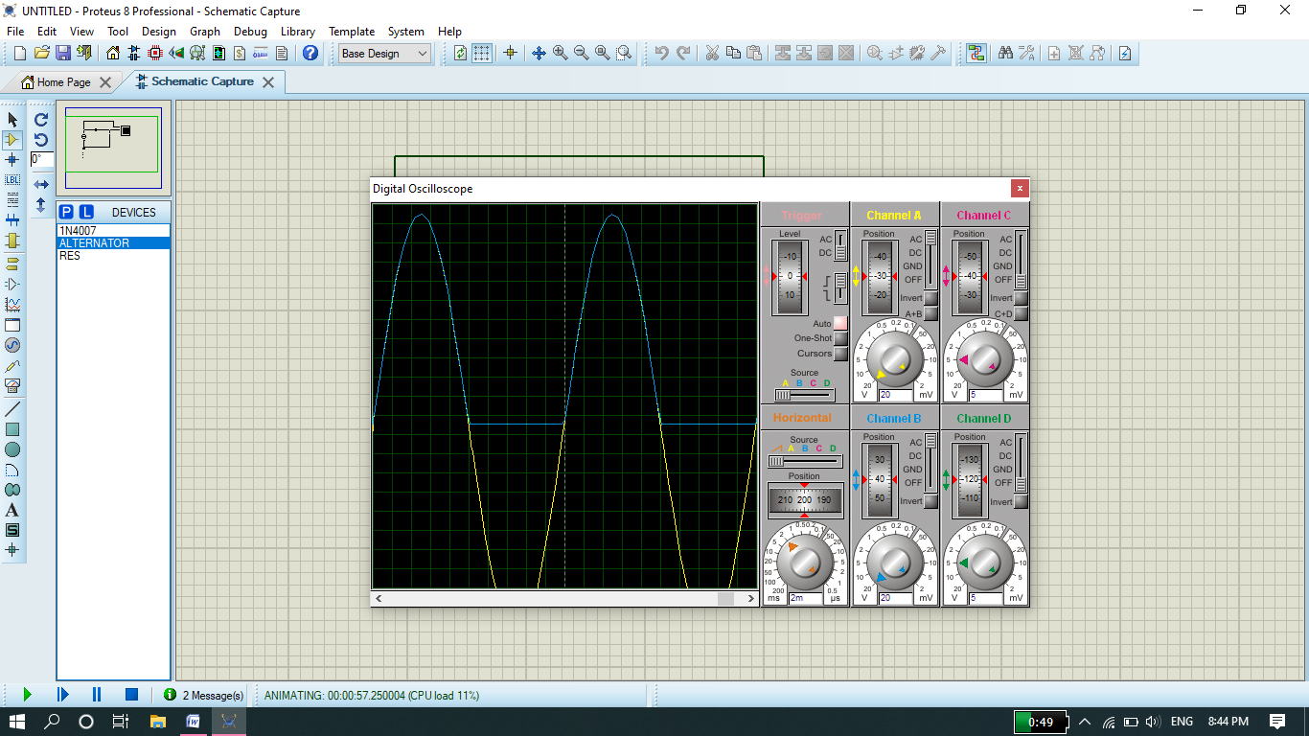

1. **Biased series clipper circuit.**

In biased series clipper circuit there is an extra Dc voltage source connects in series with diode. In case of biased, we can remove or clipped any size of portion of positive or negative half cycle. **We can increase or decrease the clipping size of the wave by DC voltage source.**

* **Positive biased series clipper.**

In this circuit a diode is connected in reverse bias in series with AC voltage source. The positive terminal of DC voltage source is connected to load resistance and negative terminal is grounded. In this case we can clip the positive half wave by any amount by using DC voltage Source.

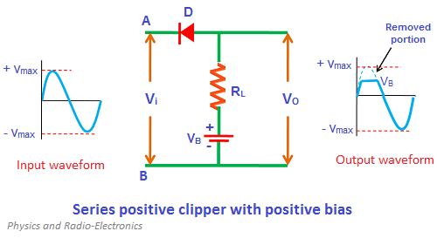

**Proteus Circuit and Output:**

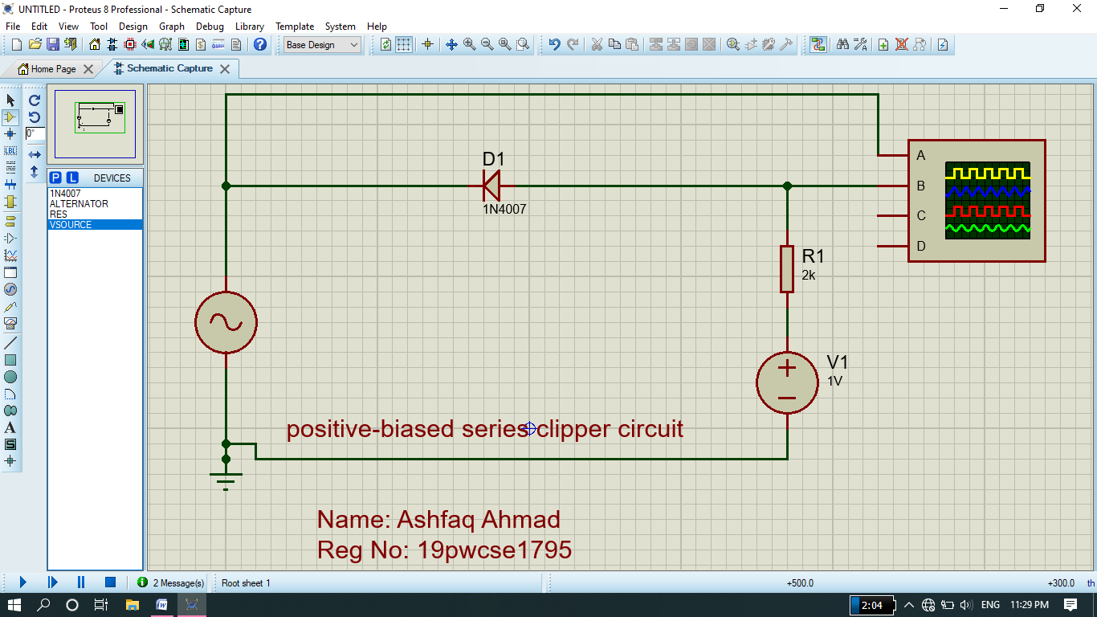

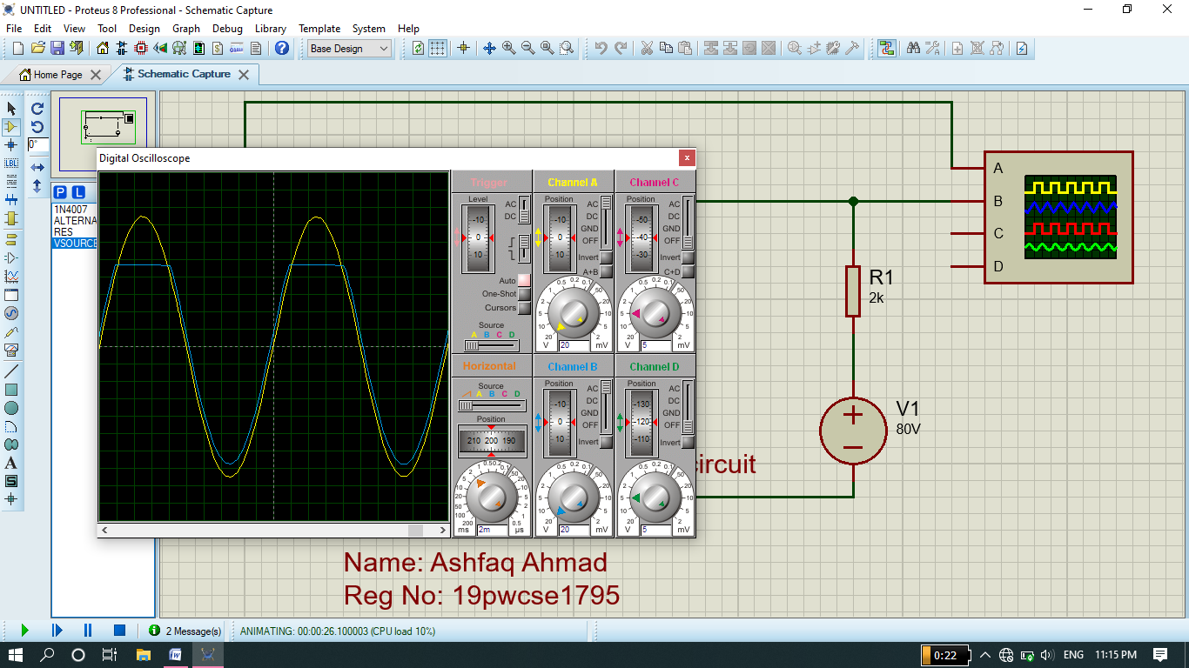

* **Negative biased series clipper.**

In this circuit a diode is connected in Forward bias in series with AC voltage source. The positive terminal of DC voltage source is grounded. While negative terminal is connected to load resistance. In this case we can clip the Negative portion of the wave by an any amount using DC voltage Source.

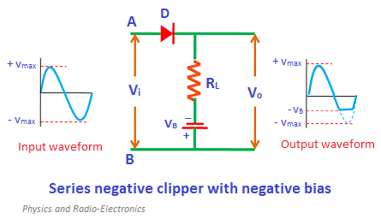

**Proteus Circuit and Output:**

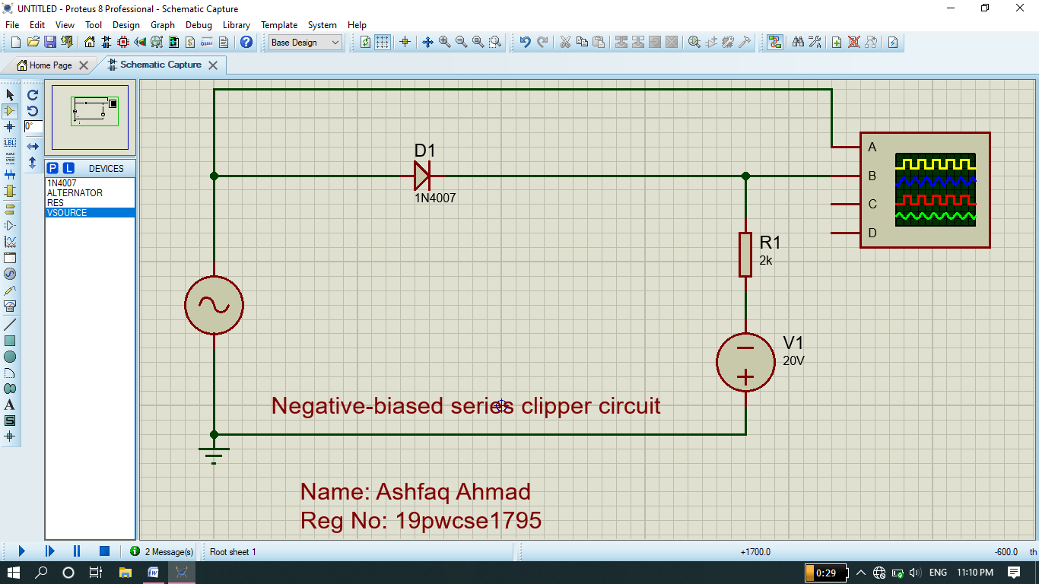

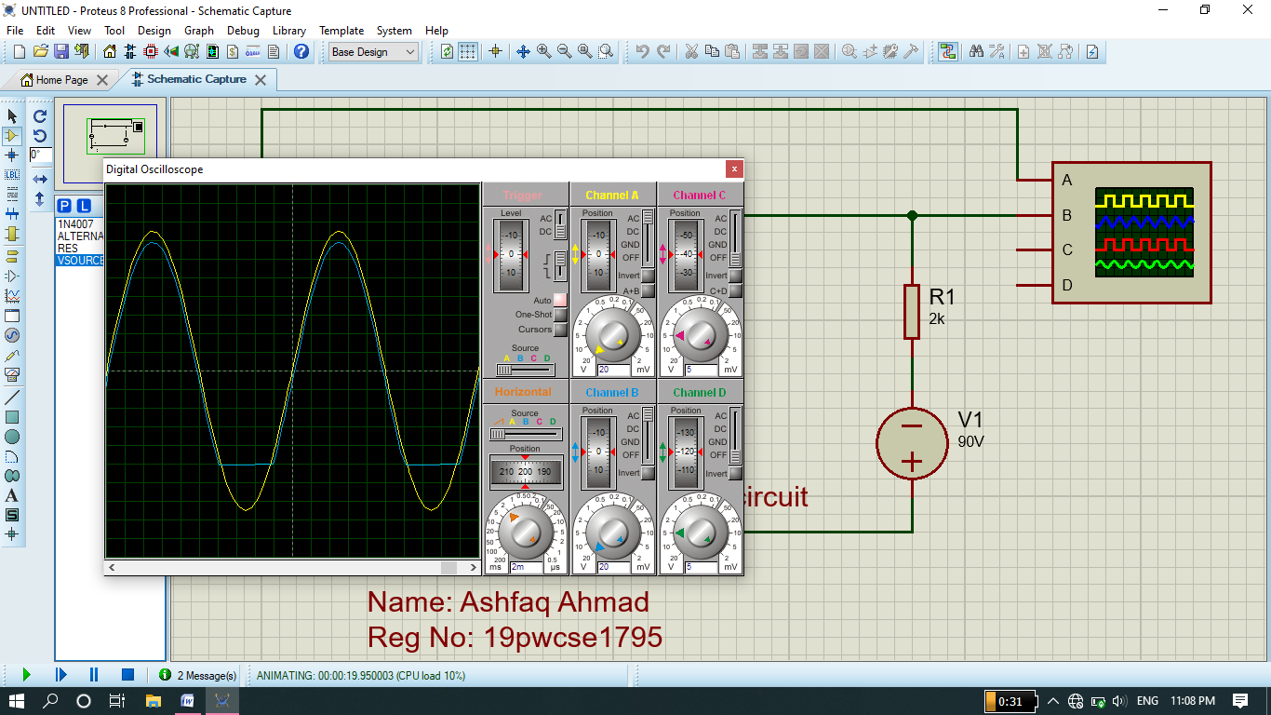

1. **Parallel clipper circuit.**

In parallel clipper circuit a diode is connect with Ac voltage source in parallel. It is also called shunt clipper circuit.

1. **Un-biased parallel clipper circuit.**

In un-biased parallel clipper circuit there is no extra Dc voltage source connects in parallel with diode. In case of un-biased, a complete positive or negative half cycle is removed.

* **Positive Un-biased parallel clipper.**

In this circuit a diode is connected in forward bias in parallel with AC voltage source. R2 is load resistance. In this circuit a positive half cycle is clipped or removed. there is still small wave in positive portion it is because in case of silicon up to 0.7v and 0.3 in case of germanium there is opposing of voltage across diode so this voltage appear across the load as output. As the output wave is not equal to input wave on negative side it is because in reverse bias there is still small amount of voltage flowing through diode which is minority charge carrier.

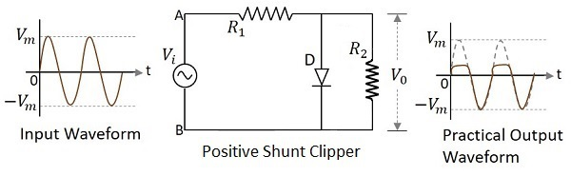

**Proteus Circuit and Output:**

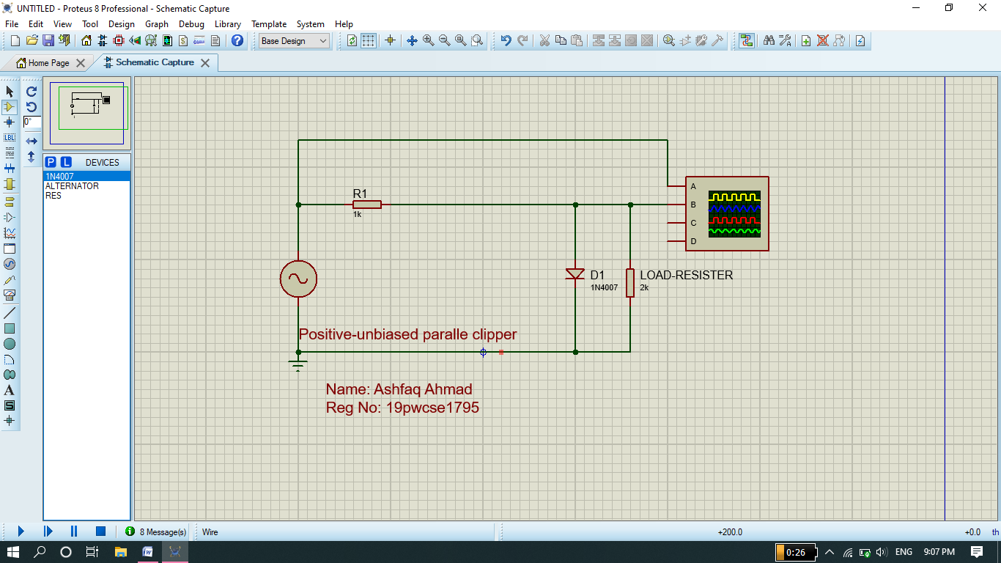

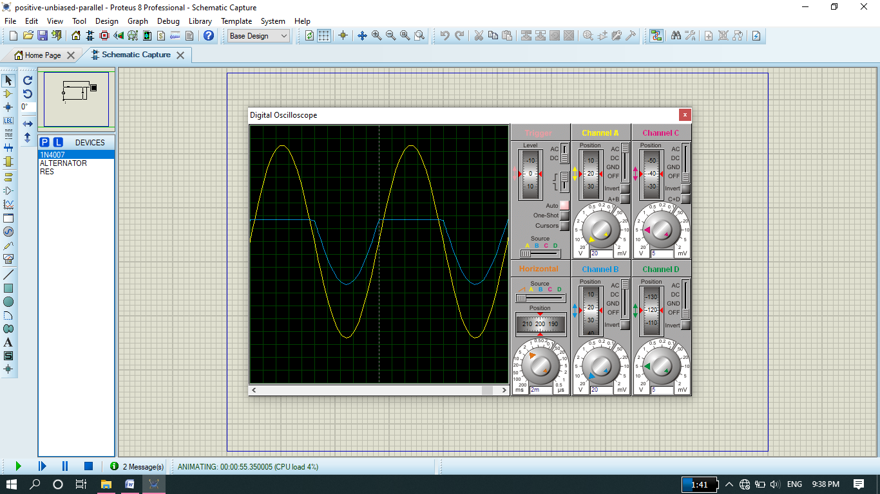

* **Negative Un-biased parallel clipper.**

In this circuit a diode is connected in reverse bias in parallel with AC voltage source. R2 is load resistance. In this circuit a negative half cycle is clipped or removed. . there is still small wave in negative portion it is because in case of silicon up to 0.7v and 0.3 in case of germanium there is opposing of voltage across diode so this voltage appear across the load as output. As the output wave is not equal to input wave on positive side it is because in reverse bias there is still small amount of voltage flowing through diode which is minority charge carrier.

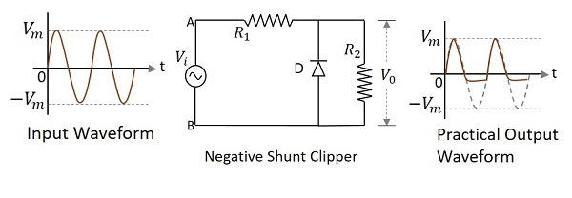

**Proteus Circuit and Output:**

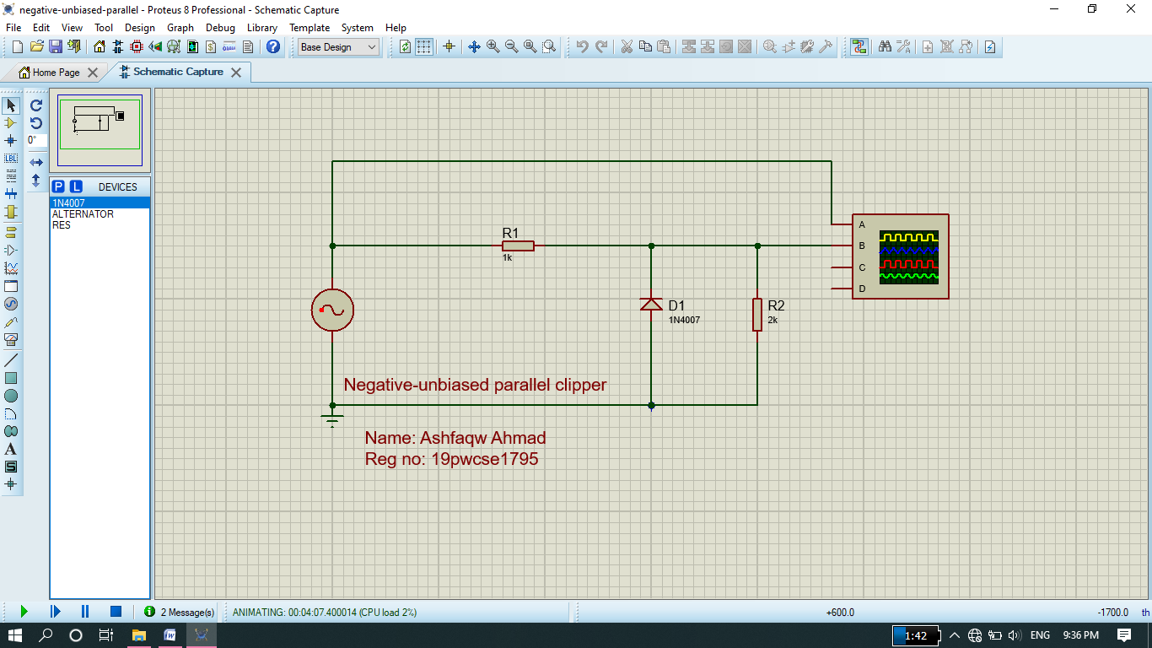

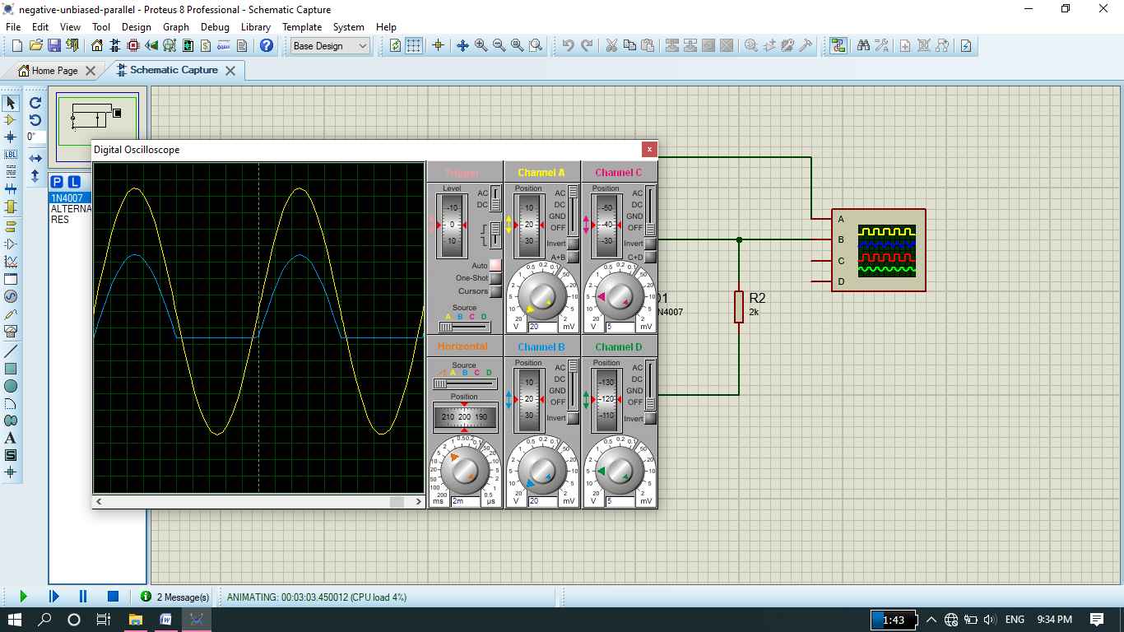

1. **Biased Parallel clipper circuit.**

In biased parallel clipper circuit there is an extra Dc voltage source connects in parallel with diode. In case of, bias only small portion of positive or negative half cycle is removed or clipped. **We can increase or decrease the clipping of the wave by DC voltage source.**

* **Positive biased parallel clipper.**

In this circuit a diode is connected in Forward bias in parallel with AC voltage source. The positive terminal of DC voltage source is connected to load resistance and negative terminal is grounded. In this case a small portion of positive half cycle is clipped.

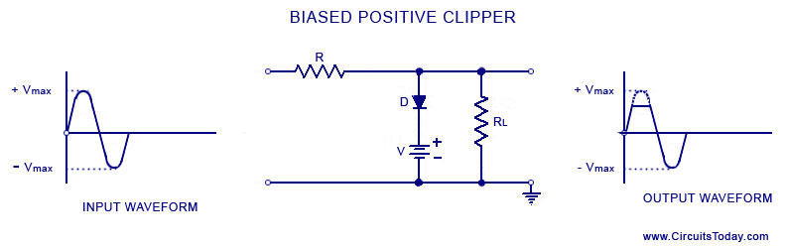

**Proteus Circuit and Output:**

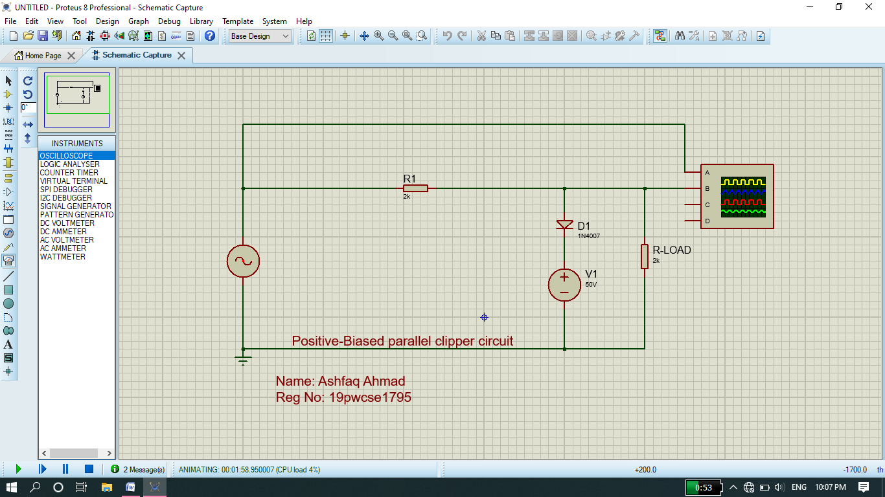

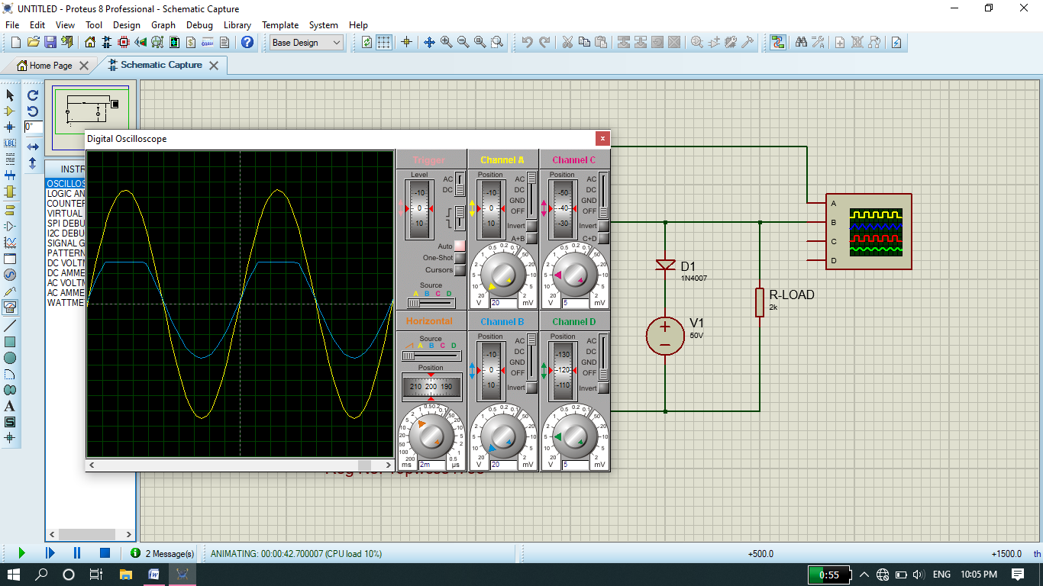

* **Negative biased parallel clipper.**

In this circuit a diode is connected in reverse bias in parallel with AC voltage source. The negative terminal of DC voltage source is connected to load resistance and positive terminal is grounded. In this case a small portion of negative half cycle is clipped.

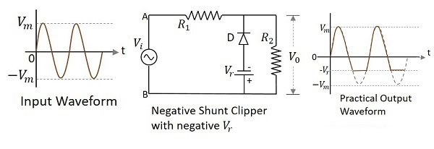

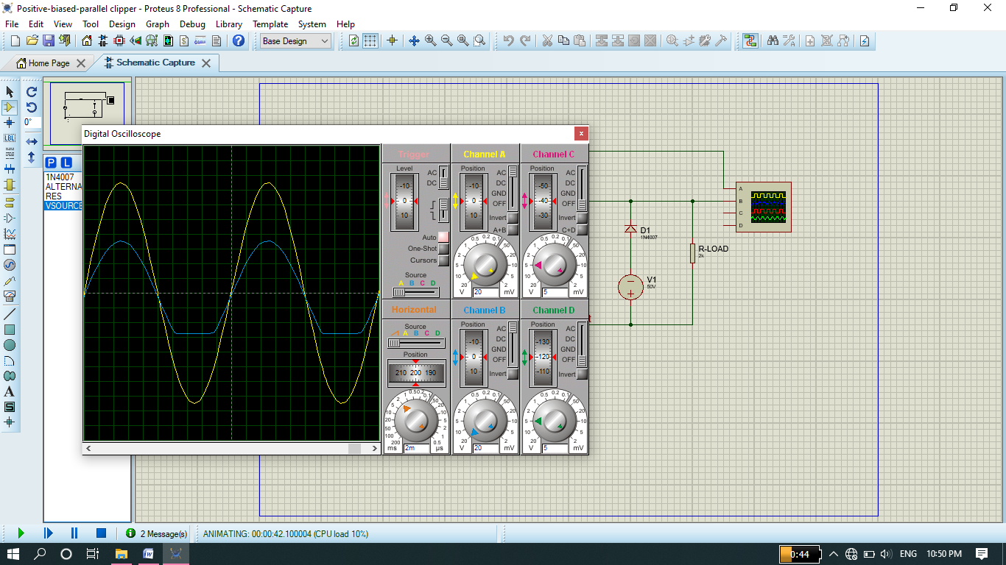

Conclusion:

* **Positive series clipper:** During positive half of cycle input voltage is positive therefore diode is reversed biased and act as open circuit hence output is zero. During negative half input voltage is negative because the polarity of AC voltage source change, therefore diode is forward biased and act as a closed switch and hence all the input voltage drop appear across the resistor.
* **Positive biased series clipper:** here same procedure occur which occurs in Positive series clipper but in case of reverse bias we provided Alternative DC voltage source by which we can increase or decrease the clipping of positive half cycle.
* **Negative series clipper:** During positive half cycle of input voltage is positive therefore diode is forward biased and act as closed switch hence all the input voltage drop appear across the resistor. During negative half input voltage is negative because polarity changed due AC voltage source therefore diode is reversed biased and act as open circuit hence output is zero .
* **Negative biased series clipper:** here same procedure occurs which occur in negative series clipper but in case of reverse bias we provided Alternative DC voltage source by which we can increase or decrease the clipping of negative half cycle.
* **Positive shunt clipper:** During positive half cycle of input voltage is positive therefore diode is forward biased and act as closed switch hence all the voltage flows through the diode and no voltage drop across the output and output is zero. Some voltage appears it is because of minority charge carrier in diode. During negative half cycle input voltage is negative hence diode is reverse biased and act as open switch hence there is direct connection between input and output voltage so all voltage appear in negative cycle.
* **Positive Biased shunt clipper:** here same procedure occurs which occur in positive shunt clipper but in case of forward bias we provided alternative DC voltage Source by which we can increase or decrease the clipping of the positive half cycle of the wave.
* **Negative shunt clipper:** During positive half cycle of input voltage is positive therefore diode is reverse biased and act as open switch hence there is direct connection between input and output hence during positive half we get output waveform. During negative half cycle input voltage is negative therefore diode is forward biased and act as closed switch hence all the current flows through the diode and no voltage drop across the output and output is zero. Some voltage appears it is because of minority charge carrier in diode.
* **Negative Biased shunt clipper:** here same procedure occurs which occur in Negative shunt clipper but in case of forward bias we provided alternative DC voltage Source by which we can increase or decrease the clipping of the negative half cycle of the wave.

**The End**